South Australia
Crown Rates and Taxes Recovery Act 1945
An Act to authorise the sale of land in respect of which arrears of rates or taxes are payable to the Crown, and for incidental purposes.

Contents
1 Short title
2 Interpretation
3 Notice to Minister of liability of land to Crown rates or taxes
4 Power of Minister to sell land
5 Conditions for exercise of power of sale
6 Contents of notice
7 Fixing of time for sale by auction
8 Advertisement of sale
9 Combination of all lands of same owner
10 Right to pay Crown rates and taxes
11 Power of Minister to transfer or convey land
12 Statutory declaration
13 Duties of Minister and Registrar-General
14 Application of purchase money
15 Receipt of Minister or Director of Lands a discharge
16 Provisions where no bid or no sufficient bid at auction
17 Provision where insufficient bid made for Crown lease
18 Discharge of liability on sale of land
19 Saving provision
20 Application of Act to Crown mortgages etc
Schedule
Legislative history

The Parliament of South Australia enacts as follows:
1—Short title
This Act may be cited as the Crown Rates and Taxes Recovery Act 1945.
2—Interpretation
In this Act, except where the context or subject matter otherwise requires—
Crown lease means any lease or agreement for sale of Crown lands which, pursuant to Part 9 of the Real Property Act 1886, is deemed to be registered;
Crown rates or taxes or Crown rates and taxes means—
(a) any rates, charges for water, or other charges of any kind payable to the Minister of Works pursuant to the Eight Mile Creek Settlement (Drainage Maintenance) Act 1959, the Sewerage Act 1929, the Water Conservation Act 1936 or the Waterworks Act 1932;
(b) charges payable pursuant to the Irrigation Act 1994;
(c) any rates and any fines added thereto payable to the South-Eastern Drainage Board pursuant to the South-Eastern Drainage Act 1931;
(d) any tax payable to The Commissioner of Land Tax pursuant to the Land Tax Act 1936;
(e) any rates or penalties on rates payable to The Commissioner of Land Tax pursuant to the Phylloxera Act 1936;
Crown rating or taxing authority includes the Minister of Works, Minister of Irrigation, the South-Eastern Drainage Board, and The Commissioner of Land Tax;
land includes any interest in land created by a Crown lease;
Minister means the Minister of Lands;
registered proprietor includes a person who is entered in the Register of Crown Leases as the holder of a Crown lease.
3—Notice to Minister of liability of land to Crown rates or taxes
(1) In any case where any Crown rates or taxes (whether becoming due before or after the passing of this Act) in respect of any land have been due and owing for not less than three years, the Crown rating or taxing authority to which the Crown rates or taxes are payable may by notice in writing given to the Minister, request the Minister to exercise the powers conferred upon him by this Act for the purpose of recovering the Crown rates and taxes payable in respect of the land.
(2) The Minister shall thereupon ascertain whether any other Crown rates or taxes (whether becoming due before or after the passing of this Act) are due and payable in respect of the land, and shall exercise the powers given by this Act for the recovery of all the Crown rates and taxes payable in respect of the land.
4—Power of Minister to sell land
(1) For the purpose aforesaid the Minister shall have the following powers:
I Power to sell the said land:
II Power to transfer or convey the land sold.
(2) The said power of sale shall include—
(a) a power to sell the land or any part thereof either together or in lots by public auction or by private contract subject to such terms and conditions with respect to the payment of the purchase money or any other matter (including power to fix a reserve) as the Minister thinks fit;
(b) power to vary any contract of sale and to buy in at any auction;
(c) power to rescind any contract for sale and to resell without being answerable for any loss occasioned thereby;
(d) power to make such streets and roads and to grant such easements of right-of-way or drainage over the same as the circumstances of the case may require and the Minister thinks fit,
provided that the land shall not be sold by private contract unless and until the land has been first offered for sale by public auction.
5—Conditions for exercise of power of sale
(1) The Minister shall not exercise the power of sale conferred by this Act unless and until notice requiring payment of all Crown rates and taxes owing in respect of the land has been—
(a) in the case of land under the Real Property Act 1886, served on the person registered as the proprietor in fee simple thereof or as the proprietor of a Crown lease thereof by being delivered to him or by being sent in a registered letter posted to him at any address stated as his place of abode or business in any recent letter or document received from him by any Crown rating or taxing authority or at his usual or last known place of abode or business; and
(b) in the case of land not under the Real Property Act 1886, served on the owner in fee simple thereof or on the person appearing by the last memorial relating to the land in the office of the Registrar-General to be seised of the fee simple thereof, by being delivered to him or by being sent in a registered letter posted to him at any address stated as his place of abode or business in any recent letter or document received from him by any Crown rating or taxing authority or at his usual or last known place of abode or business; and
(c) served on every person appearing by the register book or any memorial in the office of the Registrar-General to have any estate or interest in the land by being delivered to him or by being sent in a registered letter posted to him at any address stated as his place of abode or business in any recent letter or document received from him by any Crown rating or taxing authority or at his usual or last known place of abode or business.
(2) If in the case of any person required by this section to be served, no such address is known, notice requiring payment shall be served on that person by being advertised once in a newspaper circulating in the neighbourhood of the land, and once in the Gazette. It shall be competent to include in any such notice lands belonging to more than one owner. Any such notice may be in the Form No 1 in the Schedule, or in a form to the like effect.
6—Contents of notice
(1) Every such notice requiring payment shall—
(a) be in writing and be dated and signed by the Director of Lands; and
(b) specify the total amounts owing in respect of Crown rates and taxes of which payment is required; and
(c) specify the land in respect of which the Crown rates and taxes are owing by a sufficient description of the land and the name of the registered proprietor in fee simple or the person seised of the fee simple thereof or of the registered proprietor of the Crown lease thereof; and
(d) include a statement that in default of payment of the amounts therein specified, the land will be offered for sale by public auction after the expiration of three months from the date of notice at a time appointed by the Minister.
(2) Subject to subsection (2) of section 5, every such notice may be in the Form No 2 in the Schedule, or in a form to the like effect.
7—Fixing of time for sale by auction
The Minister shall appoint a time not less than three months and not more than twelve months from the service of the notices required by section 5 at which the land may be offered for sale by public auction.
8—Advertisement of sale
(1) The sale shall be advertised—
(a) twice at least in a newspaper circulating in the neighbourhood of the land;
(b) once at least in the Gazette;
(c) by such further and other means (if any) as in the circumstances the Minister considers reasonable and proper.
(2) Every such advertisement shall contain a sufficient description of the land and any improvements thereon (if any).
(3) In the advertisement it shall be competent to include lands belonging to more than one owner.
9—Combination of all lands of same owner
If Crown rates or taxes are owing in respect of more than one piece of land in the name of the same owner, all the Crown rates and taxes so owing and all the said lands may be set forth in one notice requiring payment and in one advertisement of sale.
10—Right to pay Crown rates and taxes
Up to the time of the actual sale of any land for non-payment of Crown rates or taxes any person having any estate or interest in the land may pay all Crown rates and taxes then in arrear, and the costs then incurred, and thereafter the proceedings shall be stayed.
11—Power of Minister to transfer or convey land
The Minister exercising the power of sale conferred by this Act shall have power by transfer (where the land is under the Real Property Act 1886), and by deed (where the land is not under the Real Property Act 1886), to transfer or convey an indefeasible estate in fee simple in the land sold or where the land sold is comprised in a Crown lease the interest in the land created by the Crown lease, free in all cases from any mortgage, lease (other than the Crown lease), tenancy, encumbrance or charge.
12—Statutory declaration
A transfer or conveyance expressed to be in exercise of the power of sale conferred by this Act shall, if accompanied by a statutory declaration by the Director of Lands that the provisions of this Act have been complied with, be accepted by the Registrar-General as sufficient evidence that the power of sale has been duly exercised.
13—Duties of Minister and Registrar-General
(1) Where the land sold is under the Real Property Act 1886, the transfer shall, after payment to the Minister of the purchase money payable and of the necessary fees and charges for the stamping and registration of the transfer, be executed by the Minister and shall be in the Form No 3 in the Schedule, or in a form to the like effect. The Minister shall forthwith after the execution thereof cause the memorandum of transfer to be forwarded to the Registrar-General together with the appropriate fees and charges.
(2) Where the land sold is not under the Real Property Act 1886—
(a) the conveyance shall, after payment to the Minister of the purchase money payable and of the necessary fees for stamping the conveyance and the other fees and charges necessary to be paid as provided by subsection (3), be executed by the Minister;
(b) the Minister shall forthwith after the execution thereof cause the conveyance to be forwarded to the Registrar-General, together with the appropriate fees and charges and together with a request in writing to the Registrar-General to issue to and in the name of the purchaser, a certificate of title under the Real Property Act 1886 for the said land.
(3) The Registrar-General shall, on receipt of any such conveyance and request and upon payment of such fees and charges as would have been payable if the request had been an application to bring the land conveyed under the Real Property Act 1886 and without any further evidence of title or the necessity of publishing any notice of the said request, forthwith issue to the purchaser a certificate of title as aforesaid.
Before issuing a certificate of title as aforesaid the Registrar-General may require the Director of Lands to deposit with him a plan or map of the land conveyed, as if the request had been an application to bring the land conveyed under the Real Property Act 1886.
(4) Notwithstanding the provisions of the Real Property Act 1886, but subject to subsection (5), the registration of a memorandum of transfer as aforesaid or issue of a certificate of title as aforesaid shall, when the land transferred is not comprised in a Crown lease, vest in the purchaser an indefeasible estate in fee simple in the land free from any mortgage, lease, tenancy, encumbrance or charge and shall, when the land transferred is comprised in any Crown lease, vest in the purchaser the interest in the Crown lease free from any mortgage, other lease, tenancy, encumbrance, or charge. Where any transfer or conveyance is made in professed exercise of the power of sale conferred by this Act, the title of the purchaser shall not be impeachable on the ground that no case had arisen to authorise the sale or that due notice was not given or that the power was otherwise improperly or irregularly exercised; but any person damnified by an unauthorised or improper or irregular exercise of the power shall have his remedy in damages against the Minister.
(5) If any land so sold is comprised in a limited certificate of title within the meaning of the Real Property (Registration of Titles) Act 1945, and issued pursuant to that Act, the Registrar-General may, before issuing therefor an ordinary certificate of title within the meaning of that Act, require the deposit of such plans of survey or otherwise as he deems necessary.
14—Application of purchase money
The money received by the Minister arising from the sale shall be held by the Minister to be applied as follows:
Firstly, in payment of the costs, charges, and expenses properly incurred by the Minister as incidental to the sale or any attempted sale or otherwise; and
Secondly, in discharge of all Crown rates or taxes due to any Crown rating or taxing authority in respect of the land and, if the land sold is comprised in a Crown lease, in payment of all rent, principal and interest due and payable to the Crown under the Crown lease; and
Thirdly, in discharge of all rates levied under the Local Government Act 1934 and due to any municipal council or district council in respect of the land; and
Fourthly, in discharge of any mortgages, encumbrances, and charges whether registered or not, according to their respective priorities at law, so far as the same can be ascertained by the Minister; and
Fifthly, in payment of the residue of the money within twelve months after the receipt thereof to the registered proprietor of the land or to the owner in fee simple of the land or into the Supreme Court under the provisions of section 47 of the Trustee Act 1936,
and thereafter any money so paid into court shall be subject to the provisions of the said Act so far as the same are applicable; but any action for or in respect of any such moneys shall be presented within six years after payment as aforesaid of the residue into the Supreme Court, and after the expiration of the said period all moneys then in the Supreme Court to the credit of the particular trust concerned shall, if there is no such action pending or any order of the Supreme Court to the contrary, be paid into and form part of the general revenue of the State.
15—Receipt of Minister or Director of Lands a discharge
The receipt in writing of the Minister or the Director of Lands shall be a sufficient discharge for any money paid on the exercise of the power of sale conferred by this Act, and a person paying the same to the Minister shall not be concerned to inquire whether any money remains due to any Crown rating or taxing authority or to any municipal council or district council for Crown rates or taxes or other rates in respect of the land sold.
16—Provisions where no bid or no sufficient bid at auction
(1) If any land (other than land comprised in a Crown lease) is offered for sale pursuant to this Act, but no bid is made for the land at the auction or no bid equal to the amount of the Crown rates and taxes payable in respect of the land is made for the land at the auction, the Minister shall have power by transfer (where the land is under the Real Property Act 1886), and by deed (where the land is not under the Real Property Act 1886) to transfer or convey the land to the Minister.
(2) Where the land is under the Real Property Act 1886 the transfer shall be executed by the Minister and shall be in the Form No 4 in the Schedule, or in a form to the like effect.
(3) Where the land is not under the Real Property Act 1886—
(a) the conveyance shall be executed by the Minister;
(b) the Minister shall forward the conveyance to the Registrar-General together with a request in writing to the Registrar-General to issue to and in the name of the Minister, a certificate of title under the Real Property Act 1886 for the said land.
The Registrar-General shall, on receipt of any such conveyance and request, and without any further evidence of title or the necessity of publishing any notice of the said request, forthwith issue to the Minister a certificate of title as aforesaid. Before issuing any certificate of title as aforesaid, the Registrar-General may require the Minister to deposit with him a plan or map of the land conveyed, as if the request had been an application to bring the land conveyed under the Real Property Act 1886.
(4) A transfer or conveyance expressed to be in exercise of the power conferred by this section shall, if accompanied by a statutory declaration by the Director of Lands that the provisions of this Act have been complied with, be accepted by the Registrar-General as sufficient evidence that the power has been duly exercised.
(5) Notwithstanding the provisions of the Real Property Act 1886, but subject to subsection (7), the registration of a memorandum of transfer as aforesaid or issue of a certificate of title as aforesaid shall vest in the Minister an indefeasible estate in fee simple in the land free from any mortgage, lease, tenancy, encumbrance, or charge.
(6) No transfer or conveyance made in professed exercise of the power conferred by this section shall be impeachable on the ground that no case had arisen to authorise the exercise of the power or that due notice was not given or that the power was otherwise improperly or irregularly exercised, but any person damnified by an unauthorised or improper or irregular exercise of the power shall have his remedy in damages against the Minister.
(7) If the land so transferred is comprised in a limited certificate of title within the meaning of the Real Property (Registration of Titles) Act 1945, and issued pursuant to that Act, the Registrar-General may, before issuing therefor an ordinary certificate of title within the meaning of that Act, require the deposit of such plans of survey or otherwise as he deems necessary.
(8) Any land vested in the Minister pursuant to this section may be disposed of by the Minister in such manner as he thinks fit.
17—Provision where insufficient bid made for Crown lease
(1) If any land comprised in a Crown lease is offered for sale pursuant to this Act but no bid is made for the land at the auction or no bid equal to the total of the amount of the Crown rates and taxes payable in respect of the land and the amount of any rent, principal, or interest due and payable to the Crown under the Crown lease is made, the Minister, notwithstanding the provisions of any other Act, may direct in writing that the Crown lease is cancelled.
(2) The Minister shall cause a copy of the direction aforesaid to be given to the Registrar-General who shall cancel the Crown lease by inscribing thereon "Cancelled pursuant to the provisions of section 17 of the Crown Rates and Taxes Recovery Act 1945", and, notwithstanding the provisions of the Real Property Act 1886, the land shall thereupon be deemed to be Crown lands free from any mortgage, lease, tenancy, encumbrance, or charge and shall be dealt with as Crown lands under the Crown Lands Act 1939.
(3) If any Crown lease is cancelled in professed exercise of the powers conferred by this section, the cancellation shall not be impeachable on the ground that no case had arisen to authorise the exercise of the power or that due notice was not given or that the power was otherwise improperly or irregularly exercised, but any person damnified by an unauthorised or improper or irregular exercise of the power shall have his remedy in damages against the Minister.
18—Discharge of liability on sale of land
Any sale of land by the Minister pursuant to this Act or any transfer or conveyance made pursuant to section 16 or any cancellation of a Crown lease pursuant to section 17 shall discharge the land and all owners and occupiers thereof and all previous owners and occupiers thereof from—
(a) all liability for payment to any Crown rating or taxing authority of any Crown rates or taxes payable in respect of the land at the time of the sale, transfer, conveyance or cancellation, as the case may be;
(b) all liability to any municipal council or district council for rates or other moneys due to the council for any purpose which at the time of the sale, transfer, conveyance, or cancellation, as the case may be, were a charge upon the said land or which were otherwise recoverable pursuant to any Act by the council in respect of the said land;
(c) all liability for payments of any rent, principal, or interest due and payable to the Crown at the time of the sale or cancellation, as the case may be, under any Crown lease in which the land is comprised.
19—Saving provision
The provisions of this Act shall be construed as being in addition to and not in substitution for the provisions of any other Act providing for the recovery of Crown rates or taxes or the recovery of rates or other amounts payable to municipal councils or district councils or the recovery of any rent, principal or interest payable under any Crown lease and, subject to the provisions of section 18, any powers of any Crown rating or taxing authority or of any municipal council or district council to take any proceedings under any other Act for the recovery of any Crown rates or taxes or other rates or other amounts and any powers under any other Act for the recovery of any such rent, principal or interest, shall not be limited or affected by the provisions of this Act.
20—Application of Act to Crown mortgages etc
Any reference in this Act to any mortgage, lease, tenancy, encumbrance, or charge shall include a reference to any mortgage, lease, tenancy, encumbrance or charge in favour of the Crown, the Government of the State, or any instrumentality, branch or department of the said Government.

Schedule
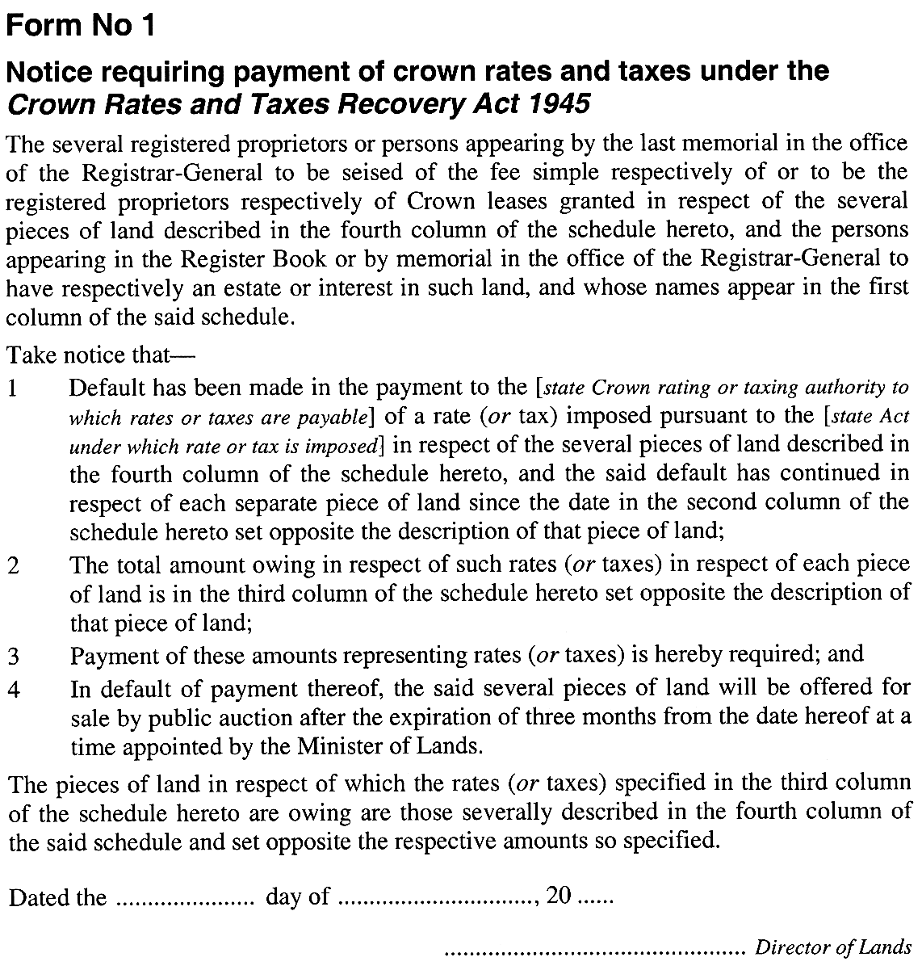
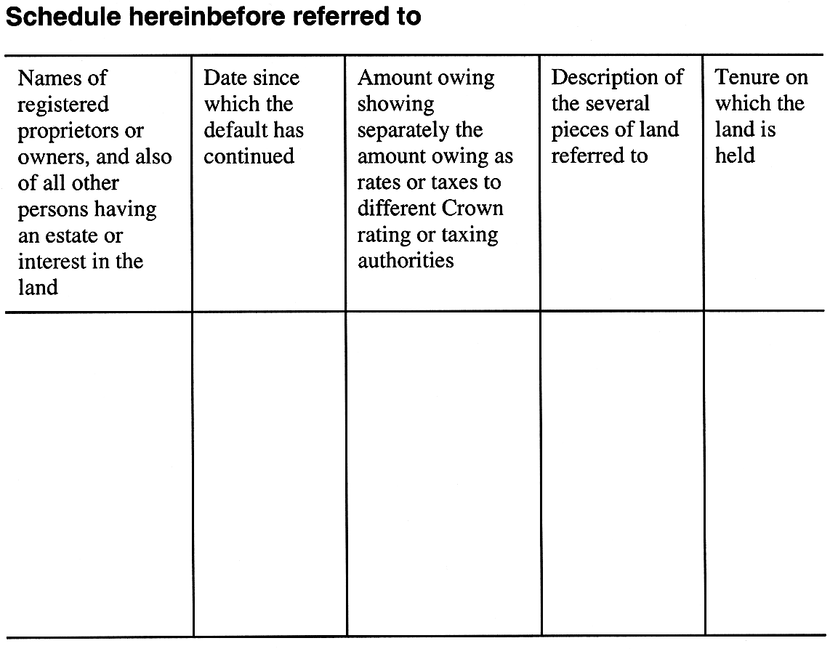
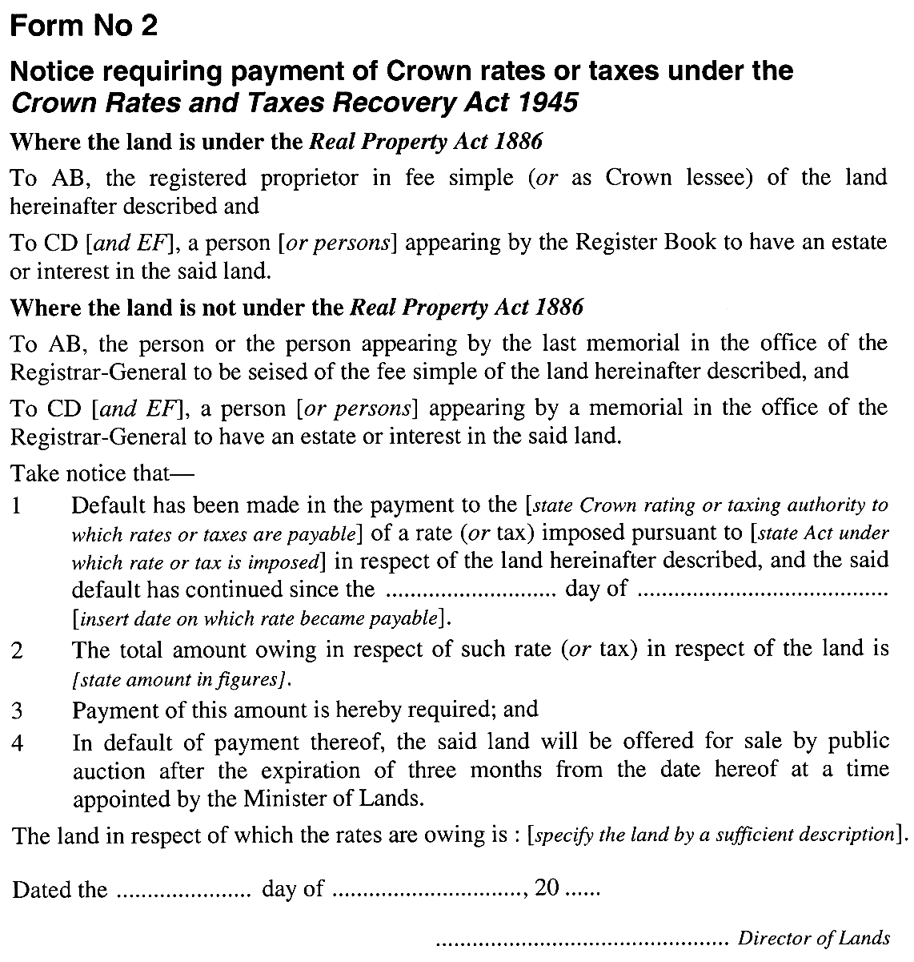
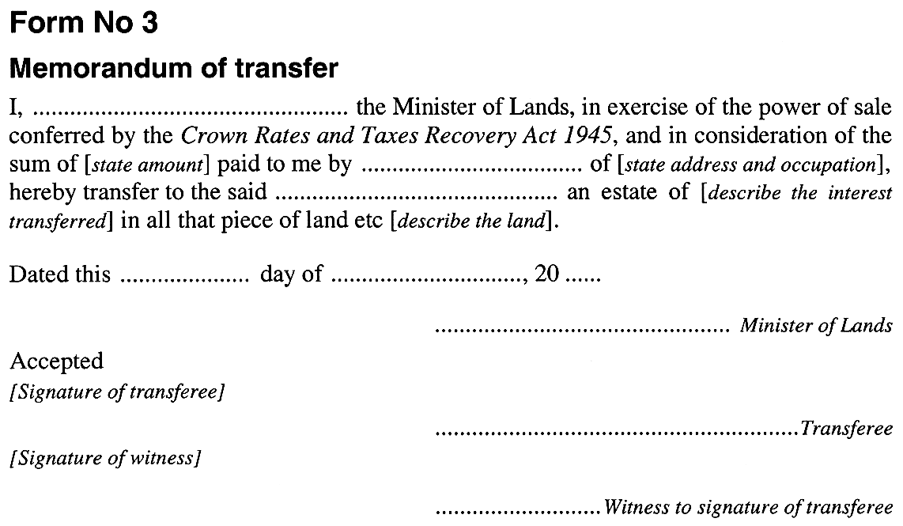
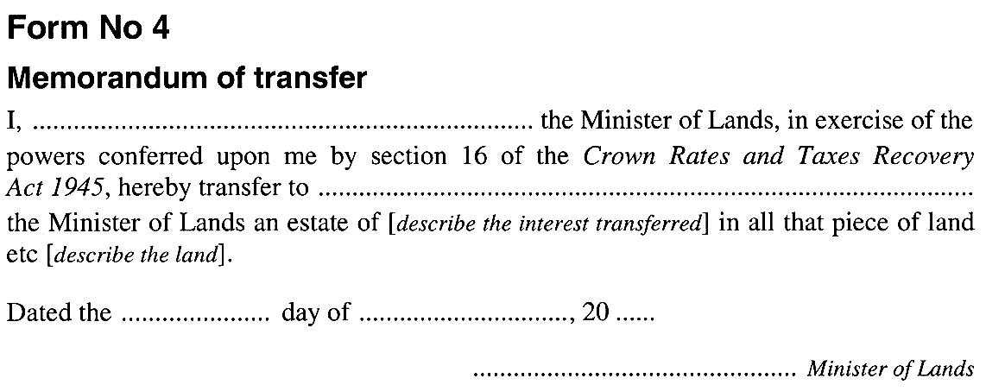

Legislative history
Notes
• Please note—References in the legislation to other legislation or instruments or to titles of bodies or offices are not automatically updated as part of the program for the revision and publication of legislation and therefore may be obsolete.
• Earlier versions of this Act (historical versions) are listed at the end of the legislative history.
• For further information relating to the Act and subordinate legislation made under the Act see the Index of South Australian Statutes or www.legislation.sa.gov.au.
Principal Act and amendments
New entries appear in bold.
Year | No | Title | Assent | Commencement
1945 | 23 | Crown Rates and Taxes Recovery Act 1945 | 20.12.1945 | 20.12.1945
1977 | 42 | Eight Mile Creek Settlement (Drainage Maintenance) Act Amendment Act 1977 | 15.12.1977 | 1.5.1978 (Gazette 20.4.1978 p1256)
1994 | 39 | Irrigation Act 1994 | 2.6.1994 | 1.7.1994 (Gazette 30.6.1994 p1842)
2006 | 17 | Statutes Amendment (New Rules of Civil Procedure) Act 2006 | 6.7.2006 | Pt 25 (s 105)—4.9.2006 (Gazette 17.8.2006 p2831)
2016 | 29 | Real Property (Electronic Conveyancing) Amendment Act 2016 | 16.6.2016 | Sch 2—4.7.2016 (Gazette 30.6.2016 p2761)
Provisions amended since 3 February 1976
New entries appear in bold.
Provision | How varied | Commencement
s 2
Crown rates or taxes | amended by 42/1977 s 10(2) | 1.5.1978
 | amended by 39/1994 Sch 3 | 1.7.1994
s 13
s 13(6) | deleted by 29/2016 Sch 2 | 4.7.2016
s 14 | amended by 17/2006 s 105 | 4.9.2006
Historical versions
Reprint No 1—1.7.1991
Reprint No 2—1.7.1994
4.9.2006

